**Test Plan & Test Cases-Hotel Reservation System**

* **Introduction -** Testing is important part of building any application or system, in order to check everything is perfectly working as expected and for quality purpose. Whatever functions are requested to the system it is perform them all in proper way.

Test cases are the documents which consist of preconditions, expected result, test data, steps wise process to test the required conditions. It can be explained as giving some input value we get the required output.

* **Objective –** Following are the objectives of the testing-

1. Main objective of to identify the system or parts to be tested.
2. Test Case help in making systematic documents with all details, prerequisites, test data and expected results.
3. It helps to find which approach should best for the system to work perfectly as expectations of the user.

* **Testing Approach-** There are various approach that can be used for testing such as system testing, integration testing, regression testing and unit testing.
* **Test Case for Hotel Reservation System**- I had following test cases for Hotel Reservation System-

1. **TC_001-Test the login functionality for hotel reservation.**

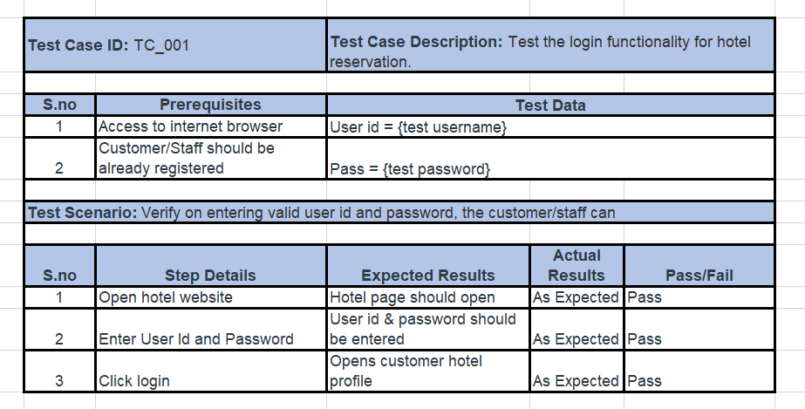

1. **TC_002-Test that user can check availability for selected room type**

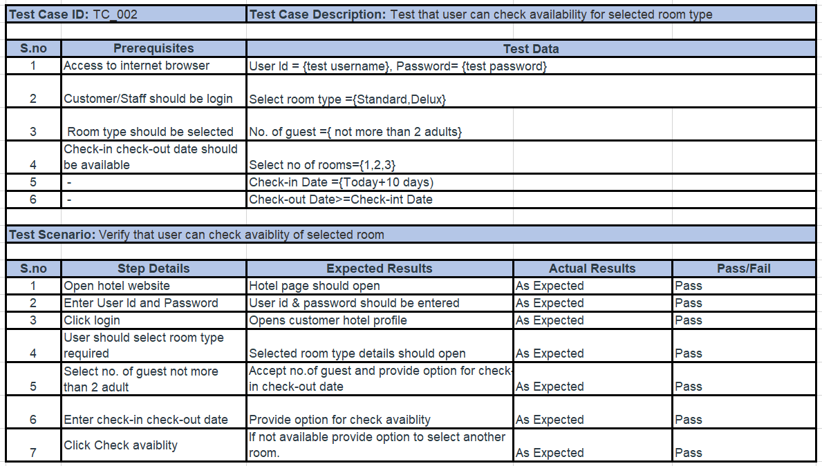

1. **TC_003- Test that user can make valid reservation**

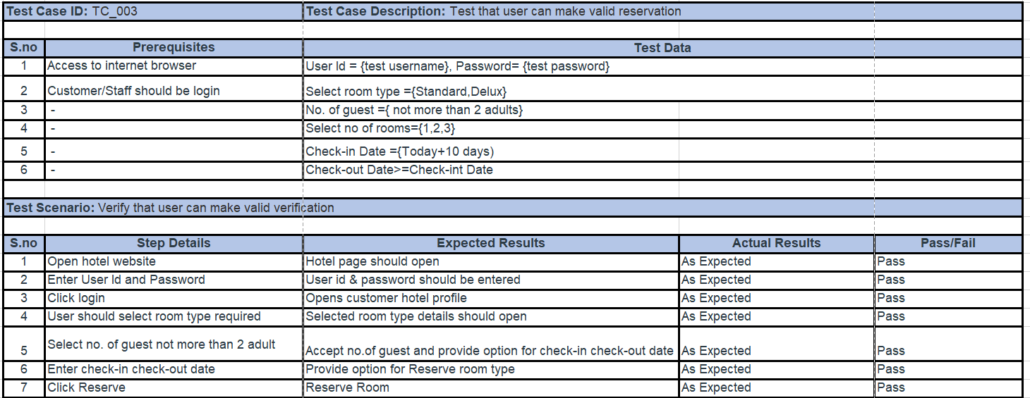

1. **TC_004 - Test that user can update reservation.**

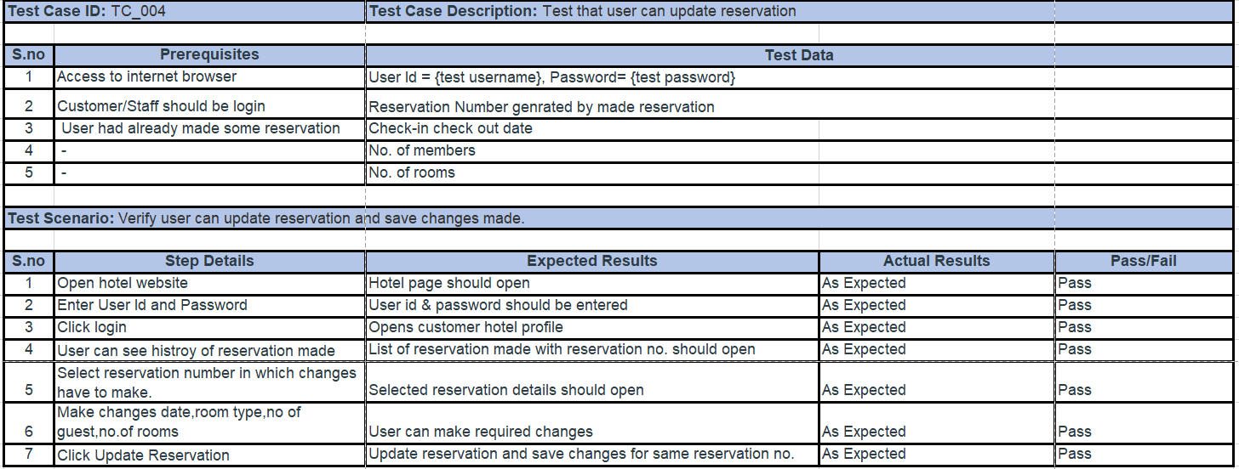

1. **TC_005- Test that user can cancel reservation.**

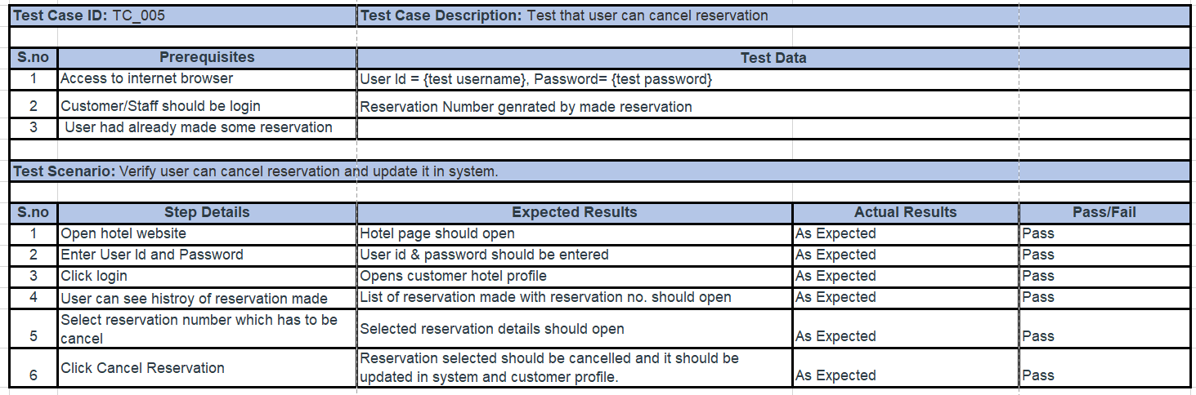

1. **TC_006- Test that receptionist can track check-in & check-out**

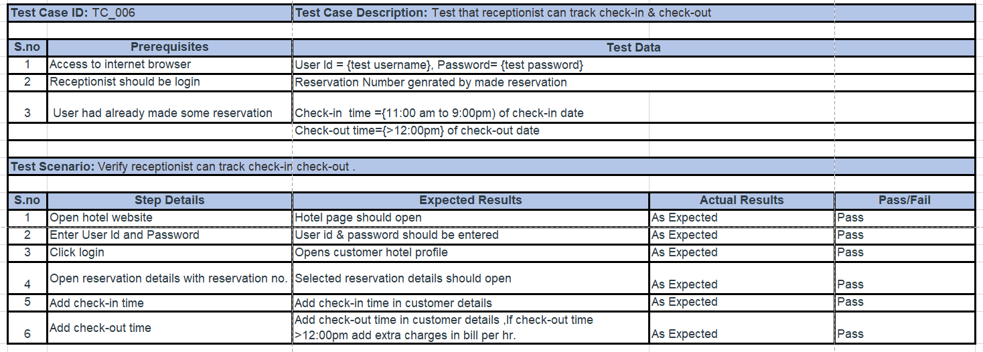

1. **TC_007- Test user can apply promotional/coupon code.**

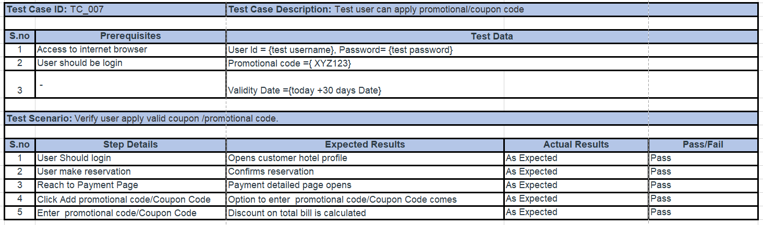

1. **TC_008- Test user can generate bill.**

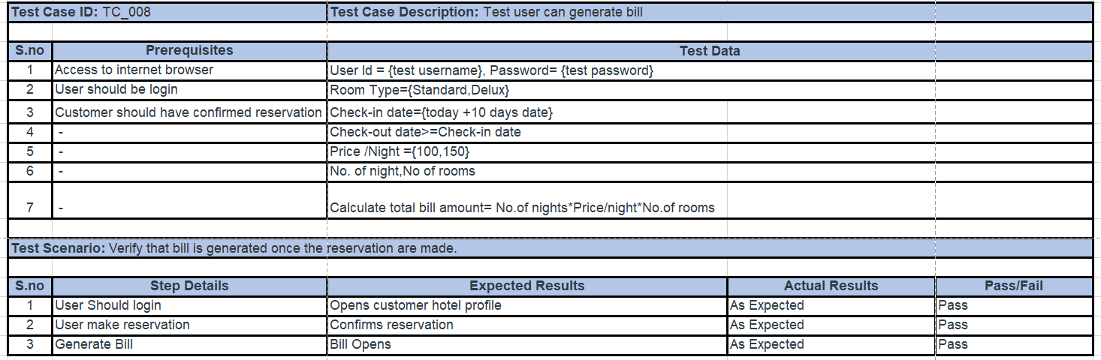

1. **TC_009- Test user can make payment.**

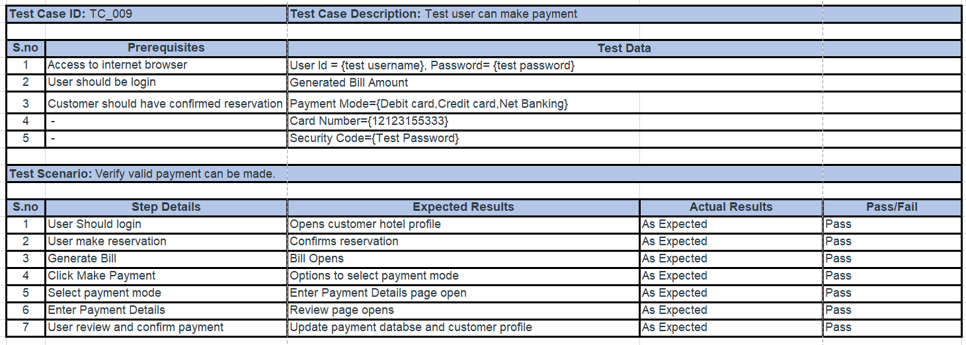

1. **TC_010- Test manager can update financial database.**

